# Setting Up and Using Folio

## What is Folio?

Throughout your time at CSB/SJU, you will build a personal electronic portfolio or “ePortfolio.” Your ePortfolio will help you track your academic progress. You get lifetime access after graduation for free, and it can also serve to demonstrate your skills and experiences to potential employers. Your ePortfolio will be developed and hosted using Folio which is also called Canvas Student ePortfolios. Begin building your ePortfolio with Step 1. If you already have an ePortfolio started, skip to Step 2.

## Step 1: Getting Started with Folio

* To access Folio, click on “Account” in Canvas then click on “Folio.”

* On the Folio landing page in Canvas, click on your name or any link on the Folio landing page. You will be taken to your Folio account home page.

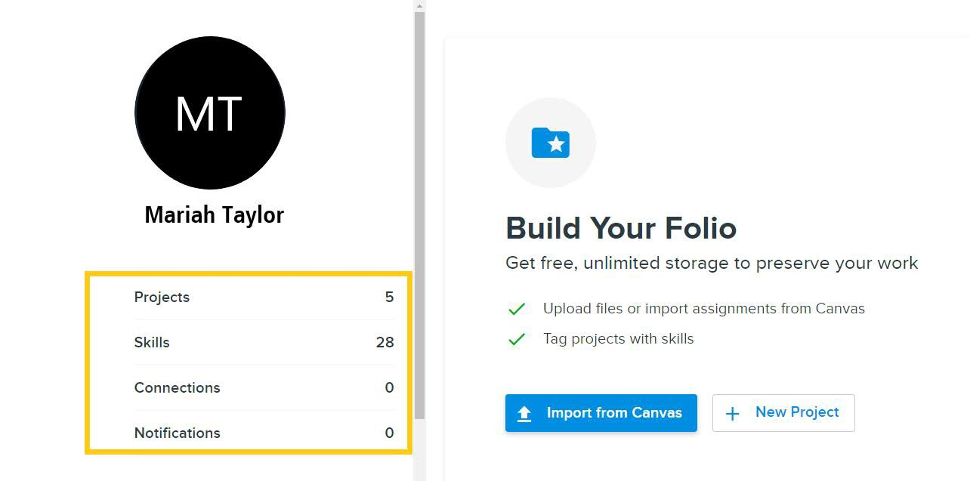

* Once on your Folio home page, click on the Edit button to customize your profile.

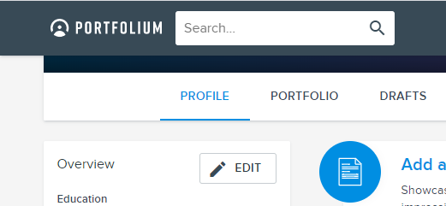

Complete the following:

* Avatar (may be a picture or other avatar to represent you)
* Cover image
* Tagline
* Introduction

## Step 2: Creating a Project for a Canvas Assignment

1. Log in to Canvas
2. In the Global navigation, click on "Account" then click on “Folio.”

1. Click the +New Project button:

1. Fill in the page that opens.

1. For “Category” choose the one that best fits the course. If course category is not there, select “Other.”
2. In “Description,” describe what the artifact is either by copying and pasting what the professor provided you or (if the professor did not provide any language) a brief (one to three sentence) description of what the artifact is.
3. Upload your artifact either by dragging and dropping the file into the web browser or clicking on “Upload files” and search for your artifact (screenshot below).
4. Use the cog at the top  to check the visibility settings for this project:

In the visibility settings, choose either the "Public" or "Portfolium Members" option so your professor can see your project. It is best to make things public so when you share your profile with future employers they can see evidence of your work. If, however, you need to restrict access in any way this is where you’d do it.

1. Use the Publish button at the bottom to make this project visible:

1. Click on “Share” then “Copy Link to this Project”



1. Paste the link you just copied to the Canvas assignment and click “submit assignment.”

